Chin-Chin Yap
All Aboard the Art Express!

Wang Qingsong, one of the most saleable artists working in Chinese photography today, adroitly captures the prevailing spirit of contemporary Chinese art scene in his recent work “Art Express Bus”. Taken in the dry heat of the countryside in Beijing's outskirts in the summer of 2002, the photograph depicts an unruly pack of poorly-clad people jostling to get onto two beaten-up buses festooned with scarlet banners and the signs "Art Express" and "China <—> World." Scrawled directions on a makeshift signpost point the ways to the Venice Biennale, Istanbul Biennale, Documenta, Qingsong Biennale, Songzhuang Biennale, Biennale of Hell, and Biennale of Heaven. Against a serene summer sky, black smoke catapults from the buses. The scene is both realistic and discomfiting, as if one had inadvertently stumbled upon these would-be modern-day Cinderellas scrambling for places aboard an undisguised pumpkin.

Wang's works, which parody contemporary Chinese attitudes of consumerism and worship of the West, owe much of their popularity to their cheerfully subversive portraits of culture and money—two ruling points of departure in contemporary Chinese photography. As market concerns and foreign influences have subsumed political and ideological concerns in everyday life, so have ideologically-based forms of art—orthodox art and movements which formed in resistance, notably Political Pop and Cynical Realism—been surpassed in favor of examinations of social reality. Not surprisingly, in this reality money is the only god. The internationalization and commercialization of Chinese art has freed it from ideological debates, promoting, in form, a diversity of schools and, in content, the multiple discourses of postmodern existence. As the post-Cold War era has led to a deconstructed multiplicity of cultural roles, this has opened up new territory for Chinese artists to discover unique modes of expression. Exploration of a new modernity, however, is always more difficult than the opposition of existing powers. It is often said that China's pace of cultural development lags behind its breakneck speed of economic progress. The resulting disjunctures in everyday reality and psychological impact are hot topics of contemporary artists. The artists themselves, however, are also enthusiastically cooperative in riding the "New China" wave, as shown by the Art Express Bus.

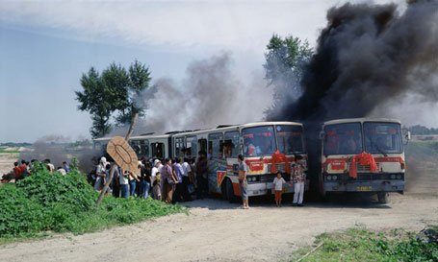
Art Express Bus, Wang Qingsong
C-print, 120 x 200 cm, 2002

Conceptual art is one school which has found recent favor, having dual significant roles in the expansion of both form and content. One of them, as satirically pointed out by the destination of the Art Express, is to further the inherent questions of Chinese contemporary art as an art form in the global art market significantly under the power of the Western media, institutions, and other systemic forces. The other is to articulate the fissuring and illusions of everyday reality which appear in a society in constant transition, attempting to negotiate cultural roles and national identity in the global arena. Conceptual art had already begun in China in the 1980s with the Xiamen Dada group, led by Huang Yongping, but became more widespread in the 1990s with movements such as Beijing's East Village artists, the most well-known of which are Zhang Huan, Ma Liuming, and Rong Rong, and the Big Tail Elephant movement in Guangdong. The regionally specific characteristics of the world's most populous nation is also borne out in the artistic sensibilities of different cities which have developed in the past decade. While the capital's art scene remains intently self-conscious and oppressively conceptual, revisiting themes of identity, the body, and symbols of post-Orientalist culture, the Pearl River Delta's greater economic freedom and liberal lifestyles have generated an urbane, sensual Southern aesthetic playing off the experiences of youth culture, urban life, and material desire. By comparison, Shanghai-based artists, true to the city's history of foreign influence and the locals' excessive pride in such, are among the most slickly cosmopolitan and xenophilic in approach.

In recent years, particularly since the late ‘90s, photography has taken off as the preferred medium for conceptual expression by artists throughout China. As a medium it is democratic and accessible, facilitating rapid, automatic production and experimentation with a broad range of other media. Photography also contains inherent traits, such as the perceived capturing of reality and time, which artists can exploit to articulate crises of contemporary existence. The illusions of seamlessness engineered through duplication, manipulation, and other technological sleights of hand manifested in the surfaces of modern China are key points of departure for conceptual photography. With the flood of images inundating contemporary life— arresting centrally-planned cityscapes, obsession with the newest technology, and glossy advertisements of the good life—present reality and future aspiration have been shrewdly packaged into billboards, postcards, and digital thumbnails, among a panoply of other image-based products of desire. The appeal and power of images naturally lies in their universality and accessibility; however, they are also sign and signifier in a closed circuit of insatiable consumer-driven desire. The significance of conceptual, photography-based art thus depends upon the artist's ability to evoke what Roland Barthes termed punctum in Camera Lucida: studium is the photograph as a set of cultural and coded symbols (the advertisement), whereas punctum arises not from the coded nature of the photograph, but rather lies in personal sensation or reflection produced by the conscious act of looking (the work of art).
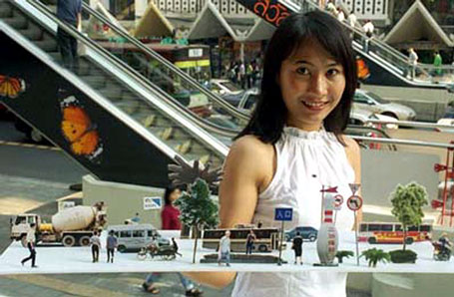
Sorry, It's Too Easy, Chen Shaoxiong
photograph, 2001, Courtesy of Eastlink Gallery

Look, then, through the lens itself—what lies there? Favored themes of conceptual artists are the city, architecture, and self-portraiture—ideas which address the evolution of the urban and intellectual environment. There are several incisive, playful takes on photography's perceived futility as an objective record in the accelerated pace of urban development. The Guangdong-based artist Chen Shaoxiong's "Sorry, It's Too Easy" series shows miniature three-dimensional streetscapes formed by painstaking cutouts of items the artist has photographed in the streets of Guangzhou—trees, passerbys, bus-stops, McDonald's signs—a diorama which no longer exists in real time by the time it is pieced together for the photograph. The actual photographs are taken in Bangkok, and in each the model street scene is dished up by a young, fresh-faced woman with the cheerful beam of your local fast-food serving-maid, poking fun at the seeming ease with which contemporary life—and the illusion of capturing it through photography—is handed to us. A rising star from Hainan, the southermost island of the People's Republic touted as China's Hawaii, Weng Peijun eloquently captures the mixed anxiety and aspiration of China's next generation in his "Sitting on the Wall" series. Each work in the series features a lone schoolgirl in immaculate plaid perched on a wall and baring some leg, overlooking the cityscape of an industrialized city in southern China. The cities in his works are the southern Chinese boomtowns—Guangzhou, Haikou, Shenzhen—which crested on the fervor of economic development in the last two decades; however, half of these imposing skylines are actually composed of abandoned developments, products of an overzealous real estate boom which bottomed out. We cannot ascertain the expressions of these schoolgirls, who have their backs to the viewer as they observe these empty hulks stranded on the horizon—their bets on the future of these cities are as good as ours.
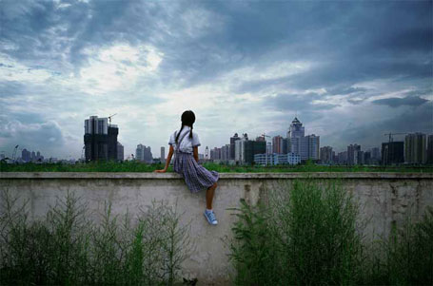
Sitting on the Wall - Guangzhou (2), Weng Fen
C-print, 125 x 175 cm, 2001

As a direct reference to the technologically-driven, fragmented nature of postmodern life, photomontage and computer manipulation are often employed to convey the arbitrary, often chaotic impressions of urban architecture that comprise our sensory realities. These works are often most effective in exaggerated dimensions, as proven in Xiang Liqing's five-panel Matrix-like photographic work at the 2002 Shanghai Biennale which shows a colossal wall of low-rent, scruffy apartment buildings in lurid hues, seemingly without apparent end in any direction.

One of the most elegant documents of life in the Chinese capital is Wang Jinsong's "City Wall." It is a collage of a thousand photographs of Beijing, most of which are black and white shots of modern highrises interspersed with a smattering of color shots of traditional pavilions, boxing matches, tranquil greenery, passersby, and precise, wistful details such as a framed rooster trinket. The thousand photographs are neatly pieced together like bricks in a wall; some of the most evocative are white spaces which the artist has left blank, akin to shards of sensory impression lost through memory dump. The viewer "reads" rather than "sees" the work as a visual narrative of contemporary life in Beijing, punctuated by the tender, irrelevant details which memory coagulates around like remnants of a dream.

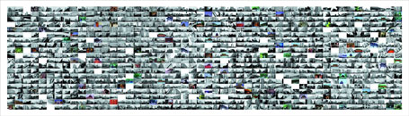
City Wall - Beijing,
Wang Jinsong, 2001

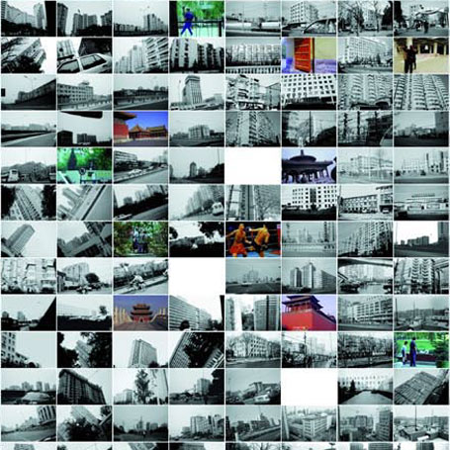
City Wall - Beijing (detail),
Wang Jinsong, photograph, 2001

Luo and Wang's works are among the few which resonate in the viewer's temporal as well as visual understanding, employing language over symbol to express the time/space effect. This convergence of the senses strongly reminds us of the fluid, interlinked multitude of external stimuli which form our transitory impressions of everyday life. More than architectural commentary, however, the contrast between old and new also raises questions of the direction of contemporary thought and experience: namely, the tensions between the fragile symbols of tradition and the unknowns of a monolithic modernity which is both feared and desired. The sum of our experience exceeds its parts, and one purpose of art is to bring out that additional, intangible essence—one which cannot be reduced to image or language, but rather resides in the ambiguous zone of interpretation and memory.

Concerns of social memory are also addressed from different angles in self-portraiture. The emergence of the individual as subject, either as physical form, citizen, or anonymous figure, is a reaction against the iconography of personality cults in revolutionary and unorthodox art. More importantly, it heralds a new attentiveness to individual psychology and the shifting status of the individual in relation to social units. Chinese history has traditionally emphasized the importance of the group over the individual in feudal, revolutionary, and post-revolutionary society. The status of the individual is first associated with his family, especially in rural society, and then with his work unit and his hometown. An ancient saying which is still tossed around today as idle threat posits that a wrongdoer could expect vengeance not only on himself but upon his extended family and future generations. This group mentality has been gradually eroded in the last two decades by individualization and personalization, particularly among the younger generation and in urban areas.

The shift of the individual's previously marginal status to center stage is creatively voiced by several artists who pose as voyeur, people's representative, and artist—ciphers for the desires and anxieties which lay siege to the self. Wang Qingsong's early works stars the artist as every imaginable fashionable icon: beggar, prisoner, war hero, Buddha, Christ; his fickle transformations of identity reflect the equally capricious fads with which people mindlessly enamor their souls and bodies. A darker, existentialist take is Yang Fudong's The First Intellectual which features a businessman apparently gone mad in the center of a Shanghainese street, brandishing a brick, himself bloodied and in disarray. Is this the fate of the thinking mind in a relentlessly material-obsessed society, to be relegated to a Kafka-esque sub-reality of dementia where the only escape is through madness or death? The examples go on; the point, perhaps, is not primarily the role models of the fickle masses, but rather anxiety about the space for intellectual development, and the creation of new ideas rather than the recycling of existing concepts. This is also an issue pertinent to economic and social development, which perhaps remains hardest to address in the realm of the intellectual.

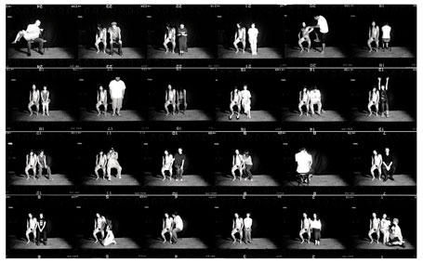
Fen/Ma Liuming in Nagano, Ma Liuming
photograph, 1999

Perhaps the ultimate cipher can be found in the figure of the performance artist Ma Liuming, whose most well-known performance Fen/Ma Liuming has taken place in almost twenty cities around the world. In these works Ma, who is naturally blessed with strikingly feminine looks, sits passive and nude on stage with his face made up as a woman. Audience members are invited on stage to pose with him; these poses are recorded in photographs which are afterward pieced together as large contact sheets 127 cm by 240 cm in size, each a cultural record of the audience participation from that particular city. Ironically, while much interest in this performance stems from foreign curiosity about a Chinese performance artist, Ma has never performed this work in mainland China. Amid the questions of culture, gender, and exhibitionism this work raises, a crucial detail is Ma's use of sleeping pills throughout the later performances, rendering himself a literally unconscious subject at the mercy of both audience and camera. The artist's lack of active participation, and even of conscious memory, during the actual click of the shutter is an ingenious inversion of the conscious intent which usually dominates the artist's role in producing a photographic image. Ma's sleeping beauty has been referred to as symbolic of the passive, "feminine" traits of Chinese society. More than this, though, the work reminds one of the shifting waters which Narcissus saw his reflection in: each sees his own demons and desires in the ripples, which never appear again in identical form to a second set of eyes.

A related point of departure is the role of the artist and individual in the transition from regulated codes of a group-based society to contemporary multiplicities of personal subjectivity and individual empowerment. Two interesting perspectives on this arise in the works of Zhuang Hui and Bai Yiluo, both artists who hail from the city of Luoyang in Henan Province. Zhuang, a veteran artist who participated in the Venice Biennale in 1999, is most well-known for his danwei ("work unit") photographs. This series, one of the most graceful and subtly humorous homages to the Chinese work unit, comprises panoramic black-and-white photographs taken with a rotating camera. The danwei, which has a far more pervasive power as a source of self-identification for Chinese citizens than any proletarian groupings in Europe or the U.S., used to hold the key to social benefits and acceptance for millions of citizens. This is particularly true for the teachers, street cleaners, military camps and department store workers in provinces outside Beijing who are the subject of Zhuang's works. Featuring entire work units ranging from twenty to over a hundred people, the works have in common the figure of the cheerfully dapper artist, sitting amid the workers with sly nonchalance.

Zhuang's presence, entirely unperceivable to those not clued in, is the crucial element establishing these seemingly unrevolutionary works as art. The relationship between public and private life is no longer that of mass ideology versus individual psychology, but rather a negotiated territory of identity and accountability.

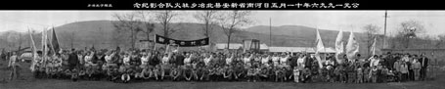
The Firemen of Beizhi Village, Xinan County, Henan Province, January 5, 1996,
Zhuang Hui, Black and white photograph, 120x476cm, 2000

Bai Yiluo is 32 and belongs to the next generation. His fascination with mass groupings is played out in enormous accumulations of flies and also those of pubic hairs, both directly exposed on film. Each work is five meters by more than two and a half meters, magnifying these minute particles into entrancing, near-abstract forms. Bai's disquieting 2001 work Citizens is composed of about seven hundred individual black-and-white headshots, crackled to different degrees, some faces almost obliterated by the white creases. The photographs are meticulously stitched together with red thread to form a colossal, mesmerizing mosaic of anonymous faces: are these citizens bound by ideology or blood, disappearing through extermination or merely the passing of time? One is reminded of a darker version of Ronald Feldman's "Farmers," or the systematic documentation of Pol Pot's victims. Zhuang and Bai's works tell different stories of the same time: one nostalgic, the other gritty and stark. Contemporary China is a neatly posed picture of disappearing unity in one, stitched together from fragments of violence and destruction in the other.

But what constitutes, then, the actual sensory fabric of modern life—what captures the air and the smell of urban China, the way Virginia Woolf wrote on Cambridge and the light which floated into the crevices of its chapels? This capability lies, not surprisingly, in the evocative works of younger artists who came of age in the '70s and '80s, growing up with the cities under the already apparent influences of Western culture. Their generation's experience of life in China is exponentially closer to those of their Western counterparts, and it is only natural that here we see unaffected inclinations towards truly global forms of art. Their models are Beuys, Rauschenberg, and Cindy Sherman; their subjects and techniques are postmodern to the core. Take, for example, Zheng Guogu's collages and photomontages such as Ten Thousand Customers. The 32-year-old Guangdong-born artist, who states with deadpan humor that "new photography is akin to love," is one of the youngest Chinese artists participating in last year's Shanghai Biennale. Zheng manipulates the debris of modern life—advertisements, tickets, digital maps—into tongue-in-cheek photomontages and collages of precisely detailed, tenderly rendered items, reminding us of the trivial beauty which is often overlooked in our fast-forwarded pace of life.

The works of Chen Lingyang, perhaps the fastest-rising female star of the young generation, play rhetorically with Chen's conceptual alter ego "Chen Lingyang No. 2." Chen is 27 and has already created some of the most refreshing, incisive satires of urban personality and consumer psychology. Another 27-year old, the exquisitely featured performance and photography artist Han Bing, possesses equally grounded and humorous anti-art sensibilities. Han's performances, which are documented through photographs, include his "Pet" series where he walks a cabbage on a leash around the streets of Beijing. Surprisingly, scant attention is paid to the odd duo, even when they ride the subway at rush hour.

And this is just the beginning. With the burgeoning of biennales from Johannesburg to Pusan, Chinese photography is exploding onto the international scene with a zealous, provocative energy, flirting with the zones of self-exploration and exploitation. It already occupies a prominent place in most major contemporary Chinese collections, and numerous international exhibitions are in the works including a large-scale production in 2004 by the Asia Society and International Center of Photography in New York. Let's get back on the bus, then, hang on, run a few lights—there's a drive-by shooting waiting to happen.

Chin-Chin Yap is a writer and manager of Courtyard Gallery, the contemporary art gallery in Beijing, China.
ArtKrush Copyright © 2002 ArtKrush, LLC. All Rights Reserved.

